Laboratory Workflows Defined (Catalonia)



1. **Laboratory workflows Definition**

With the Laboratory Working Group in Catalonia, **six workflows** were identified according to the number of centers (two or three) that interact in the process of a laboratory request, and the role developed by the center: placer (center making the request), extractor (center that extrets the sample) or filler (center that performs the test analysis).

For each workflow the sequence diagram is defined, which allows to contemplate the HL7 v2.x messages that are used between the actors that interact, and the diagram of states, that allows to identify the different states through which it can happen a request.

The possible workflows are as follows:

|  |  |  |  |
| --- | --- | --- | --- |
|  | Request | Extraction | Test analysis |
| *Workflow 1* | **Center 1** | **Center 1** | **Center 2** |
| *Workflow 2* | **Center 1** | **Center 2** | **Center 2** |
| *Workflow 3* | **Center 1** | **Center 2** | **Center 3** |
| *Workflow 4* | **Center 1** | **Center 2** | **Center 2**  **Center 3** |
| *Workflow 5* | **Center 1** | **Center 2** | **Center 1** |
| *Workflow 6* | **Center 1** | **Center 1** | **Center 2**  **Center 3** |

## Workflow 1

|  |  |  |
| --- | --- | --- |
| Request | Extraction | Test analysis |
| Center 1 | **Center 1** | **Center 2** |

1. **Center 1** creates the test request and send it to **Center 2**
2. **Center 1** extracts the sample and sends it to **Center 2**
3. The **Center 2** does the test analysis.
4. The **Center 2** send test results to **Center 1**.

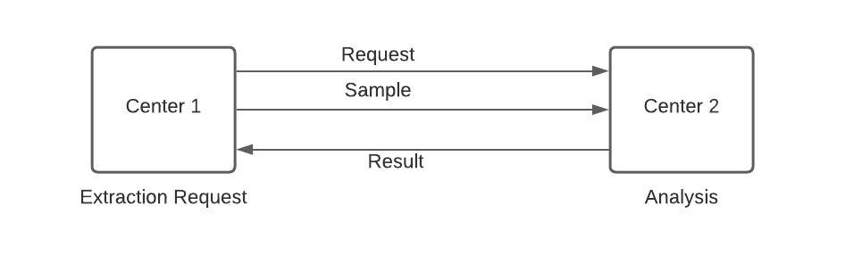

**States Diagram workflow 1:**

*Si*

Completed

*Cancelled due to errors*

*No*

**Finish**

**Finish**

**Finish**

**Start**

*Reject*

*Cancellation*

*Cancellation*

*Accepted*

*Cancel*

Requested (pending confirmation)

Rejected

Accepted (in progress)

Sample received

Cancelled

## Workflow 2

|  |  |  |
| --- | --- | --- |
| Request | Extraction | Test analysis |
| Center 1 | **Center 2** | **Center 2** |

1. **Center 1** create the test request and send it to **Center 2**.
2. The **Center 2** extracts the sample.
3. The **Center 2** does the test analysis.
4. The **Center 2** send test results to **Center 1**.

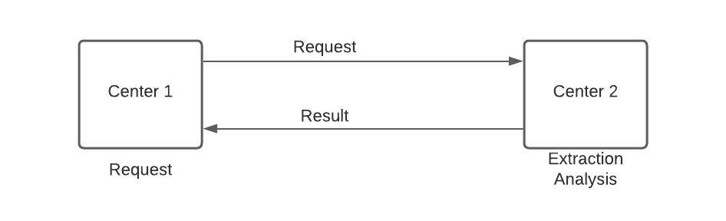

**State diagram workflow 2:**

*Reject*

*Cancel*

*Cancelled due to*

*errors*

*Cancel*

*Acceptació*

*Cancel*

New Laboratory request

**Finish**

**Finish**

**Start**

Requested (pending confirmtion)

Rejected

Acceptada (en curs)

Completed

**Finish**

*No*

*Yes*

Cancelled

## Workflow 3

|  |  |  |
| --- | --- | --- |
| Request | Extraction | Test analysis |
| Center 1 | **Center 2** | **Center 3** |

1. **Center 1** create the test request and send it to **Center 2**.
2. **Center 2** **1** extracts the sample.
3. The **Center 2** send the Request and the sample to **Center 3**.
4. The **Center 3** does the test analysis.
5. The **Center 3** send to **Center 1** the test results.

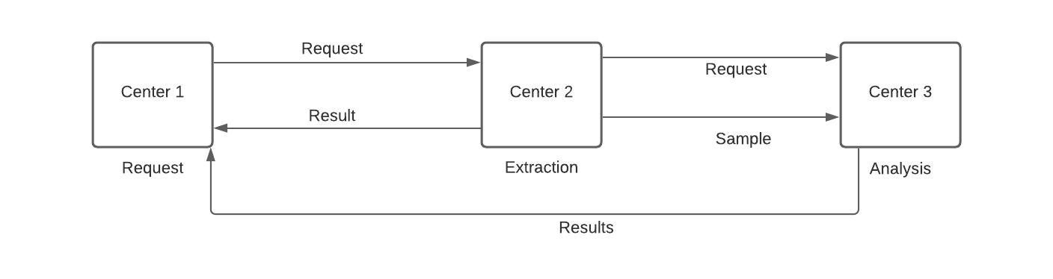

**Workflow state diagram 3:**

**End**

*Acceptance*

**Start**

**End**

**Endd**

*Rejection*

*Rejection*

*Cancellation*

*\*Only for errors*

*Cancellation*

Cancelled

*Cancellation*

Requested (pending confirmation at Center 1)

Rejected

Accepted (in progress)

Sample received

Completed

Demand (pending confirmation at Center 2)

Accepted (in progress)

*Cancellation*

## Workflow 4

|  |  |  |
| --- | --- | --- |
| Request | Extraction | Test analysis |
| Center 1 | **Center 2** | **Center 2**  **Center 3** |

1. **Center 1** creates the test request and send it to **Center 2**.
2. **Center 2** extracts the sample.
3. **Center 2** does part of the test analysis.
4. The **Center 2** sends the Request and the sample to **Center 3**.
5. The **Center 3** does the rest of the test analysis.
6. The **Center 3** sends to **Center 2** the test results
7. The **Center 2** sends the total results to **Center 1**.

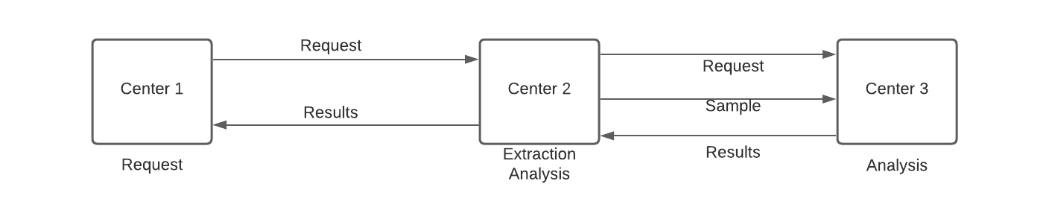

**Workflow state diagram 4:**

**End**

*Rejection*

*Rejection*

**Start**

**End**

**End**

*Cancellation*

*Cancellation*

*Acceptance*

Cancelled

*Cancellation*

Demand (pending confirmation at Center 1)

Rejected

Accepted A (in progress)

Sample received

Completed B (in Center 2)

Request B (pending confirmation at Center 2)

Accepted B (in progress)

*Acceptance*

*Cancellation*

*\*Only for errors*

Completed A (in Center 1)

## Workflow 5

|  |  |  |
| --- | --- | --- |
| Request | Extraction | Test analysis |
| Center 1 | **Center 2** | **Center 1** |

1. **Center 1** create the test request and send it to **Center 2**.
2. **Center 2** extracts the sample and sends to **Center 1**.
3. The **Center 2** send the Request to **Center 1**.
4. The **Center 1** does the test results.

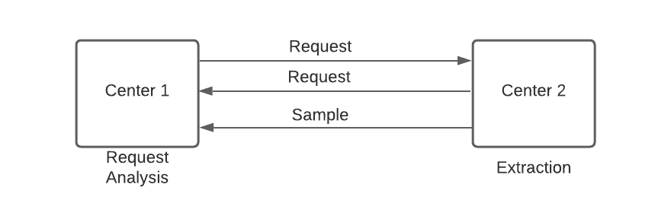

**Workflow State diagrama:**

**End**

**End**

*Acceptance (B)*

Accepted (in destination)

*Acceptance (A)*

*Rejection (B)*

*Rejection (A)*

**End**

**Start**

*Cancellation*

Rejected

Cancelled

Accepted (in origin)

Sample received

Returned (pending confirmation)

*Cancellation*

*Cancellation*

Requested (pending confirmation)

## Workflow 6

|  |  |  |
| --- | --- | --- |
| Request | Extraction | Test analysis |
| Center 1 | **Center 1** | **Center 2**  **Center 3** |

1. **Center** creates the test request and sends it to **Center 2**.
2. **Center 1** extracts the sample and sends it to **Center 2.**
3. The **Center 2** sends the request to **Center 3**.
4. **Center 2** does part of the test analysis.
5. The **Center 2** sends the sample to **Center 3**.
6. The **Center 3** does the rest of the test analysis.
7. The **Center 3** sends to **Center 2** the results.
8. The **Center 2** sends the total results to **Center 1**.

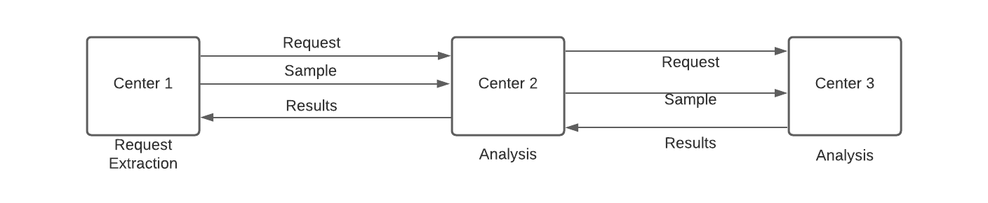

**Workflow state diagram 6:**

**Start**

Requested A (pending confirmation at Center 1)

**End**

Rejected

**End**

**End**

*Acceptance*

*Rejection (B)*

*Acceptance (A)*

*Rejection (A)*

*Cancellation*

*Cancellation*

*Cancellation*

Requested B (pendent confirmed to Center 2)

Sample received

Accepted A (in progress)

*Cancellation*

Cancelled

Sample received

Completed B (in Centre 2)

Accepted B (in progress)

*Cancellation*

*\*Only for errors*

Completed A (in Centre 1)